6.047/6.878: Lecture 18: Population Genetic Variation
(Guest Lecturer: Pardis Sabeti)

Scribe: Alex McCauley
Based on notes of Matthew Lee (2009), Arjun K. Manrai and Clara Chan (2008)

1. Introduction:

The ability to sequence find patterns in genomes is a fundamental tool in research into the evolution of organisms, especially Humans. There are various algorithms to find the similarities between the genome of our species and another, but how do we find the divergences and how long ago did they occur? In other words, how do we measure selection in the Human Genome? This lecture aims to outline the main criteria and features that are analyzed to answer these questions.

2. Polymorphisms:

Polymorphisms are differences in appearance (Phenotype) amongst members of the same species. Since all polymorphisms have a genetic basis, they can be characterized into types based on the mutation in the genome.
- Single Nucleotide Polymorphisms (SNPs)
  - The mutation of only a single nucleotide base within a sequence. In most cases, this type of change has no consequence. However, there are some cases where this causes a major change.
  - Prime example is when glutamic acid (GAG) valine (GTG) in hemoglobin and causes Sickle Cell Anemia
- Variable Number Tandem Repeats
  - When the copying machinery in the body is transcribing repeats within the genome, but loses track of how many repeats it’s made and makes more repeats then there originally was.
  - Prime example is a triple CAG repeat which cause’s Huntington’s disease where there is gradual muscle control loss and severe neurological degradation. Also an example of the phenomenon of anticipation where if it is inherited by the next generation, it becomes more severe in that generation
- Insertion/Deletion
  - When certain nucleotide bases are just forgotten to be transcribed or extra nucleotides are transcribed into a sequence
  - Worst when only 1 or 2 are deleted or added since this will shift the frame of reading codons (groups of 3 nucleotides) for instructions
  - Prime example is deletions in the CFTR gene, which codes for chloride channels in the lungs and may cause Cystic Fibrosis where the patient cannot clear mucous in the lungs and causes infection

Allele and Genotype Frequencies:

Hardy Weinberg Principle:
Allele and Genotype frequencies within a population will remain at constant equilibrium unless there is an outside influence and/or interaction

Assumptions in Hardy-Weinberg:
- All mating in the population is at random, there is no inbreeding or arranged pairings
- There is no random mutations in the population
- No migration of the species or introduction of another subpopulation into the general population; isolated
- No natural selection, all individuals have equal probability of survival
- The population observed is very large
- Allele frequency drives future genotype frequency (Prevalent allele drives Prevalent genotype)

In a Hardy Weinberg Equilibrium, for two genotypes A and T, occurring with probability p and q = 1 – p, respectively, the probabilities of finding the homozygous AA or TT (pp or qq, respectively) or heterozygous (2pq) genotypes can be described by the equation:

This equation gives a table of probabilities for each genotype, which can be compared with the observed genotype frequencies using statistical error tests such as the chi-squared test to determine if the Hardy-Weinberg model is applicable.

In a small population that violates one criteria of the Hardy-Weinberg, when genetic drift (a mutation) occurs, it will always either disappear (frequency = 0) from the population or become prevalent in a species - this is called “fixation”; in general, 99% of mutations disappear. Shown below is a simulation of a mutation’s prevalence in a finite-sized population over time: both perform random walks, with one mutation disappearing and the other becoming prevalent:
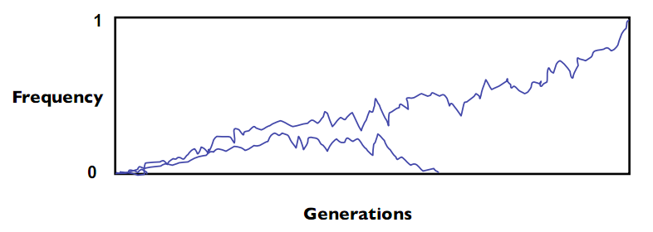
Once a mutation has disappeared, the only way to have it reappear is the introduction of a new mutation into the species population. For humans, it is believed that a given mutation, evolving neutrally, should fixate to 0 or 1 (within, e.g., 5%) within a few million years. However, under selection this will happen much faster.

Ancestral State of Polymorphisms

How do we determine for e.g., a SNP, which allele was the original and which is the mutation?
Traces of the ancestral state can be done by comparing the genomes of a species and a closely related species, or outgroup (e.g. humans and chimpanzees) with a known phylogenetic tree. Mutations can occur anywhere along this tree – sometimes mutations at the split fix differently in different populations (“fixed difference”), in which the entire populations differ in genotype. However, recently occurring mutations have not fixed, and a polymorphism will be present in one species but fully absent in the other (simultaneous mutations in both species are very rare). In this case, the “derived variant” is the version of the polymorphism appearing after the split, while the “ancestral variant” is the version shared by both species. There is one caveat – perhaps 1% of the time, something more complex (e.g. double mutations) may occur, and this simple model does not hold.

Measuring Derived Allele Frequencies

The derived allele frequency (i.e., the frequency of the derived variant in the population) can be very easily measured. In doing this there is an implicit assumption that the population is homogeneous. However, in fact there could be some unseen divide between two groups that cause them to evolve separately (shown below):
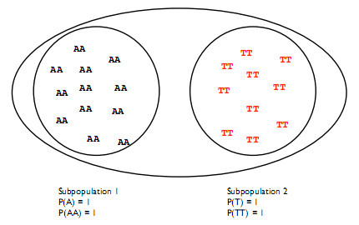
In this case, the prevalence of the variants among subpopulations is different, and Hardy-Weinberg is violated.

One way to quantify this is to use the Fixation Index (Fst) to compare subpopulations within a species. In reality, it is merely a proportion of the total heterozygosity found in a species in a given subpopulation
- Fst estimates reduction in heterozygosity (2pq with alleles p and q) expected when 2 different populations are erroneously grouped given that there is in a population n alleles with frequencies p_{i} where (1 ≤ i ≤ n ) and homozygosity, G, of the population is given by:
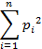
And the total heterozygosity in the population is given by 1 - G

In the case of the figure above, there is no heterozygosity between the two populations, so Fst = 1.
In reality within one species (ex: humans) the Fst will be small (0.0625). For actual tests, Fst is computed either by clustering sub-populations randomly, or using some simple/obvious characteristic, e.g., ethnicity.

3. Genetic Linkage

The Second Law in Mendelian Inheritance: Law of Independent Assortment:

Alleles of different genes assort independently without influence from other alleles

When this “law” holds, there is no correlation between different polymorphisms. Then the probability of a haplotype (a given set of polymorphisms) is simply the product of the individual polymorphism probabilities.

Of course, at first sight this law seems impossible: genes lie on chromosomes, and chromosomes are passed on as units to offspring. Therefore, two polymorphisms occurring on the same chromosome should be perfectly correlated (perfectly linked). However, genetic recombination events, in which segments of DNA on homologous chromosomes are swapped, will over time reduce the correlation between polymorphisms. Over a suitably long time interval, recombination will remove the linkage between two polymorphisms; they are said then to be in equilibrium. When, on the other hand, the polymorphisms are correlated (either because they are both very recent, or as we will see below, by positive selection), we have “Linkage Disequilibrium” (LD). The amount of disequilibrium is the difference between the observed haplotype frequencies and those predicted in equilibrium.

We can use this LD measurement (= D) to find the difference between observed and expected assortments:
- If there are two Alleles (1 and 2) and two loci (A and B) we can calculate the haplotype probabilities and find expected allele frequency probabilities and compare to observed probabilities
  - Haplotype frequencies
    - P(A1) = x₁₁
    - P(B1) = x₁₂
    - P(A2) = x₂₁
    - P(B2) = x₂₂
  - Allele Frequency
    - P₁₁ = x₁₁ + x₁₂
    - P₂₁ = x₂₁ + x₂₂
    - P₁₂ = x₁₁ + x₂₁
    - P₂₂ = x₁₂ + x₂₂

  - D = P₁₁ * P₂₂ – P₁₂ * P₂₁

Using the value Dmax, the maximum value of D with given allele frequencies, it can compared to D in the relationship:
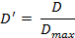
Where D’ is equal the maximum linkage disequilibrium or “complete skew” for the given alleles and allele frequencies. Dmax can be found by taking the smaller of the expected haplotype frequencies P(A1B2) or P(A2B1).
If there is full combination and complete independent sorting, then it is in complete equilibrium in which case D’ = 0 for completely unlinked. Vice versa, a value of D’=1 will demonstrate total linkage.

The key point for this lecture is that mutations that have occurred relatively recently have not had time to be broken down by Linkage Disequilibrium. Normally, such a mutation will not be very common. However, if it is under positive selection, the mutation will be much more prevalent in the population than expected. Therefore, by carefully combining a measure of LD and derived allele frequency we can determine of a region is under positive selection.

Decay of Linkage Disequilibrium is driven by recombination rate and time (in generations) and has an exponential decay. For a higher recombination rate, linkage disequilibrium will decay faster in a shorter amount of time. The hard part in the test for natural selection is actually getting the background recombination rate, as it is difficult to estimate and depends on the location in the genome. Comparison of genomic data across multiple species helps a lot in determining these background rates.

Correlation Coefficient r2
Answers how predictive is allele at locus A of allele at locus B

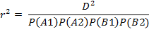

As the value of r² approaches 1, the more it can be said that two alleles at two loci can be correlated. There may also be Linkage Disequilibrium between two haplotypes, but the haplotypes are not correlated at all. The correlation coefficient is particularly interesting when studying disease mapping where information at locus A does not predict a disease where as locus B does. Or there could be the case where neither locus A nor locus B predict disease but loci AB where A1B2 does predict a particular disease. With many linkages however, we can hope to generalize and tag many haplotypes

4. Natural Selection

Mid 1800’s
There were many papers already on the theory of evolution; however, Darwin and Wallace provide mechanisms of natural selection that lead to evolution

Not until 70 years later (1948) did we have an example of how this could occur in humans: J.B.S Haldane’s “Malaria Hypothesis” showed a correlation between genetic mutations in red blood cells and the distribution of malaria prevalence. It turned out that individuals with these mutations (e.g., sickle cell mutations) had a resistance to malaria. Therefore, there is a direct environmental pressure for genetic mutation.

Another example is LCT, lactose tolerance (lasting into adulthood). However, these explicit examples were very hard to construct, since the investigators did not have genetic data. Now, in hindsight, we can search the genome for regions with the same patterns as these known examples to identify regions undergoing natural selection. This begs the question, what are these signals?

Genomics Signals of Natural Selection
Exponential prevalence of a feature in sequential generations
Mutation that helps species prosper

Tests:
- Long range correlations (iHs, Xp, EHH)
  - If we tag genetic sequences on an allele and try to reconstruct, we end up with a “broken haplotype” and the number of breaks or color changes is directly
correlated to the number of recombinations and to how old or long ago it occurred
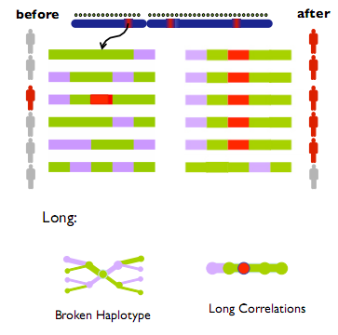
- SWEEP™ – program developed by Pardis Sabeti, Ben Fry and Patrick Varilly
  - Detects evidence of natural selection by analyzing haplotype structures in the genome and using Long Range Haplotype (LRH) test. It looks for high frequency alleles with long range Linkage Disequilibrium
    - This suggests that there was a large scale proliferation of a haplotype that occurred at a rate greater than recombination could break it from its markers

- High Frequency derived
  - Look for large spikes in the frequency of derived alleles in set positions
- High Differentiation (Fst)
  - Large spikes in differentiation at certain positions

Using these tests, we can investigate selected regions. One problem is that, while a single SNP may be under positive selection and proliferate, nearby SNPs will hitchhike along. It is difficult to distinguish the SNP under selection from the hitchhikers with only one test. Under selection, these tests are strongly correlated; however, in the absence of selection they are generally independent. Therefore, by employing a composite statistic built from all of these tests, it is possible to isolate out the individual SNP under selection.

Examples where a single SNP has been implicated in a trait:
- Chr15 – Skin pigmentation in Northern Europe
- Chr2 – Hair traits in Asia
- Chr10 – Unknown trait in Asia
- Chr12 – Unknown Trait in Africa

The International HapMap Project aims to catalog the genomes of humans from various countries and regions and find similarities and differences to help researchers find genes that will benefit the advance in disease treatment and administration of health related technologies.

Future Directions of this research
- Application to new data sets as they become available
- Additional genotyping and sequencing
- Functional validation
- Design of model organisms

